**Lab: 8**

**Statement: Accessing Array Elements and Displaying them.**

Q.1 Explain how to access array elements and to display those elements under two topics:

* Accessing array elements.
* Displaying array elements.

**Program**:

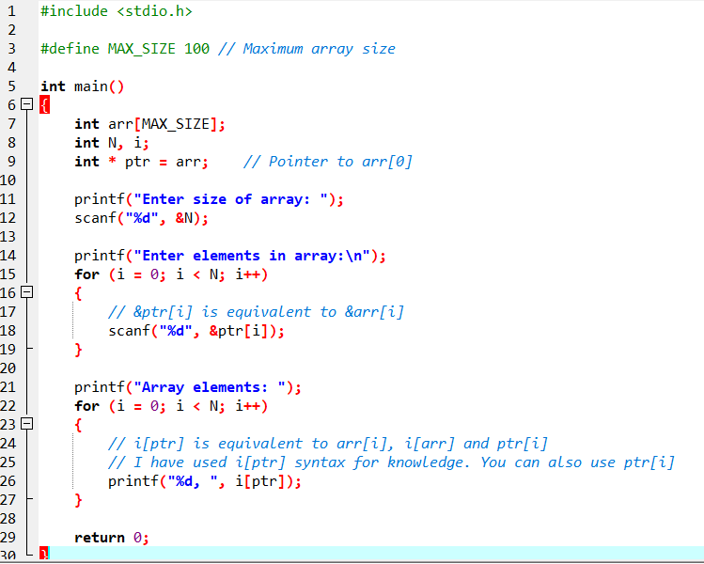

**Output**:

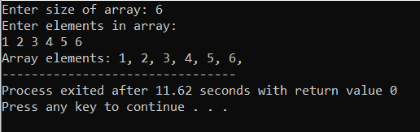

**Lab 14:**

**Statement: Call by value and Call by reference.**

**Questions:** Write a program to illustrate call by value and call by reference method of calling a function for swapping values of two variables.

**Program:**

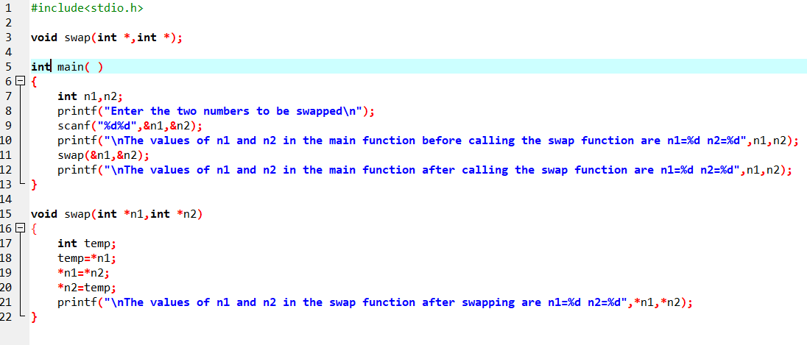

**Output**:

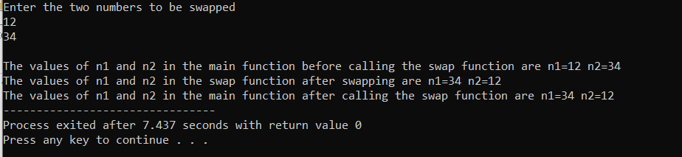

**Lab 15: Pointer.**

**Q. 1 A program to illustrate pointer declaration.**

**Program**:

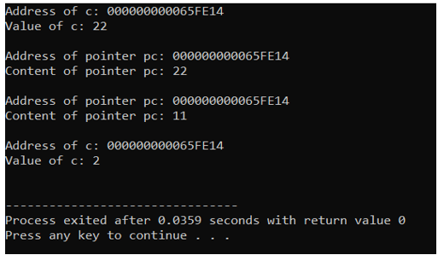

**Output**:

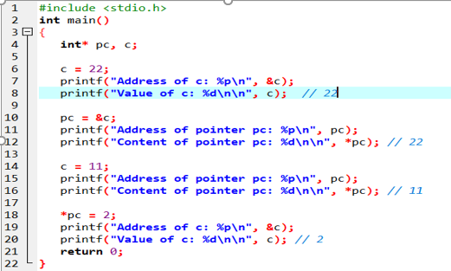

**Q.2 Program to display the contents of the variable their address using pointer variable.**

**Program**:

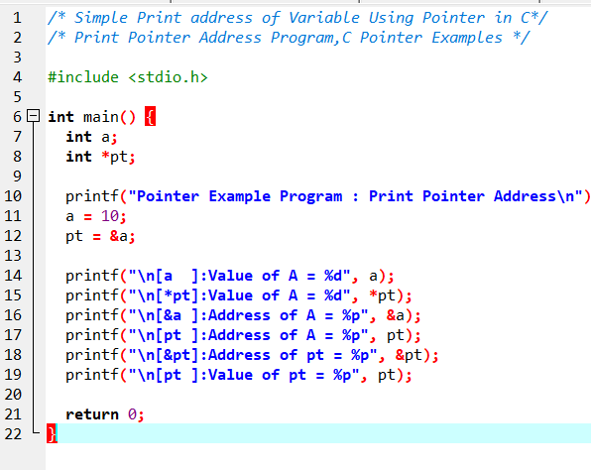

**Output**:

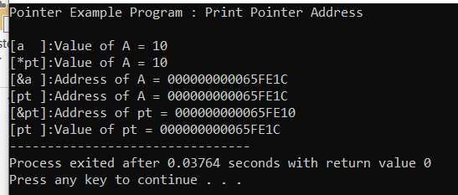

**Q.3 Program to illustrate the pointer expression and pointer arithmetic.**

**Program:**

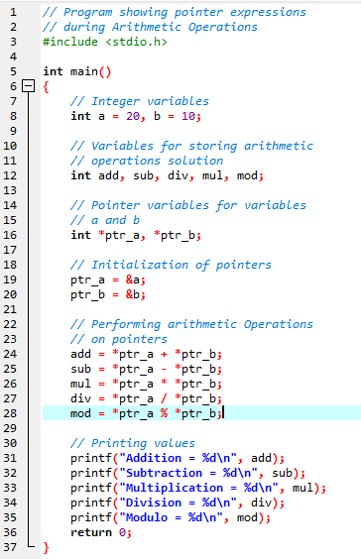

**Output**:

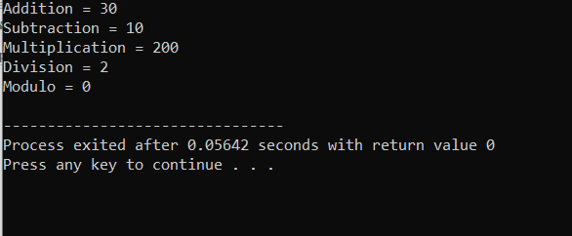

**Q. 4 Program to illustrate call by value**

**Program:**

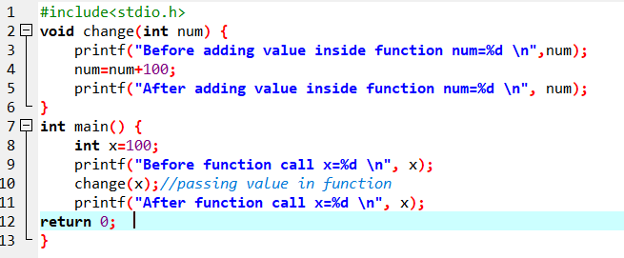

**Output**:

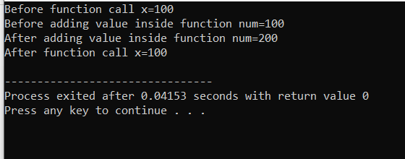

**Q.5 Program to illustrate call by reference.**

**Program:**

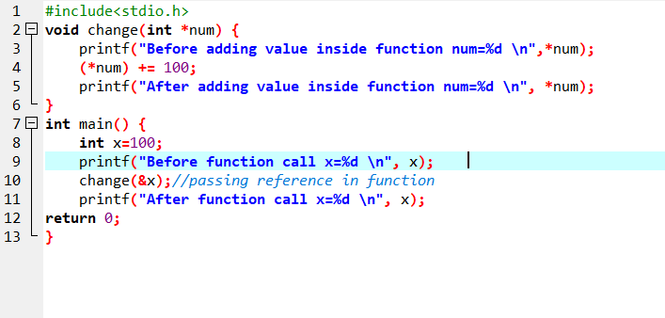

**Output**:

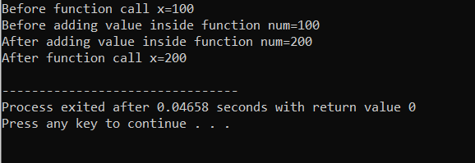

**Lab 16:**

**Dynamic memory allocation.**

**Q. 1 Write a program illustrating malloc.**

**Program:**

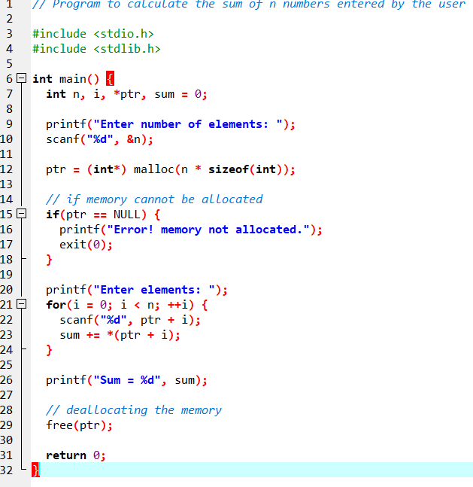

**Output**:

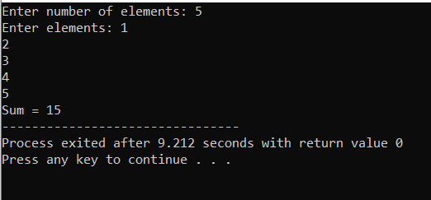

Write a program illustrating calloc.

Program:

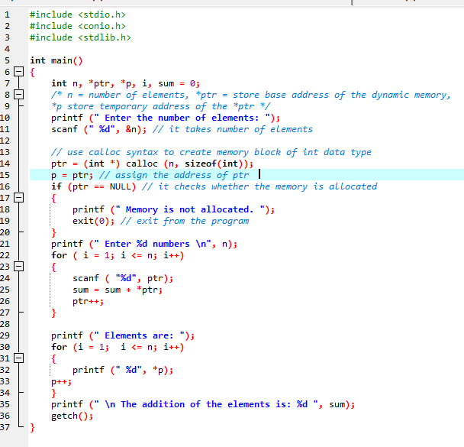

Output:

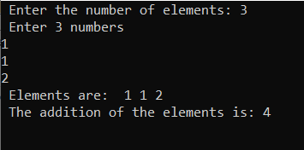

**➢Write a program illustrating realloc.**

**Program**:

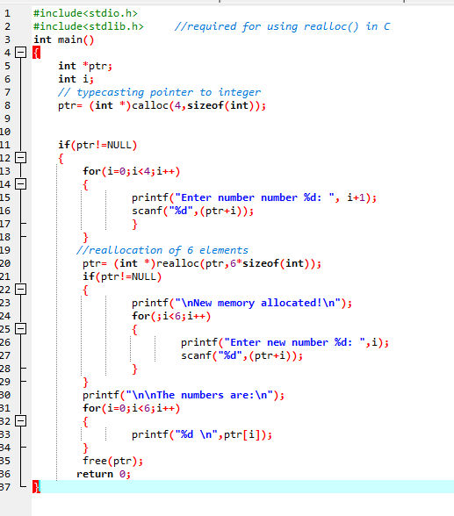

**Output**:

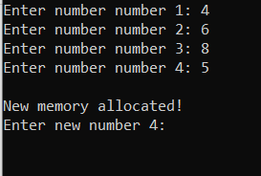

**Lab 17: File handling.**

Q.1 **Write a simple c program to open a file and store information.**

**Program**:

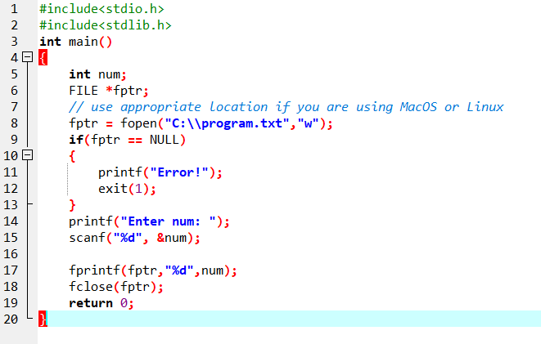

**Output:**

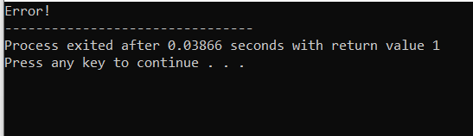

**Q. 2 Write a program illustrating getw and putw.**

**Program:**

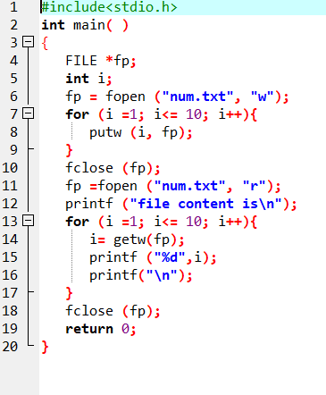

**Output:**

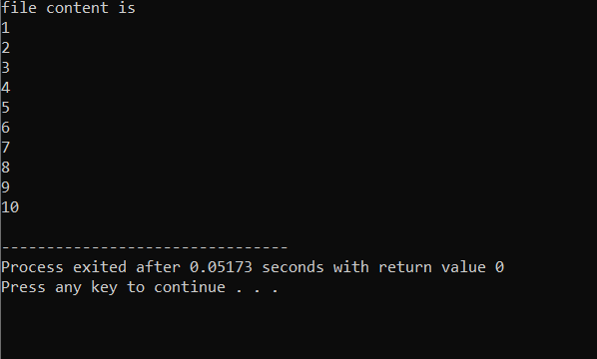

**Q. 3 Write a c program illustrating fprintf and fscanf.**

**Program:**

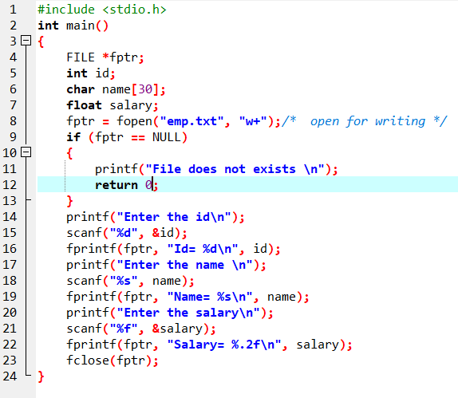

**Output:**

